1, Call verification code interface
http://140.46.13.43:6680/code/verificationCode.do
（6680 is web port, you need to change it to your web port）
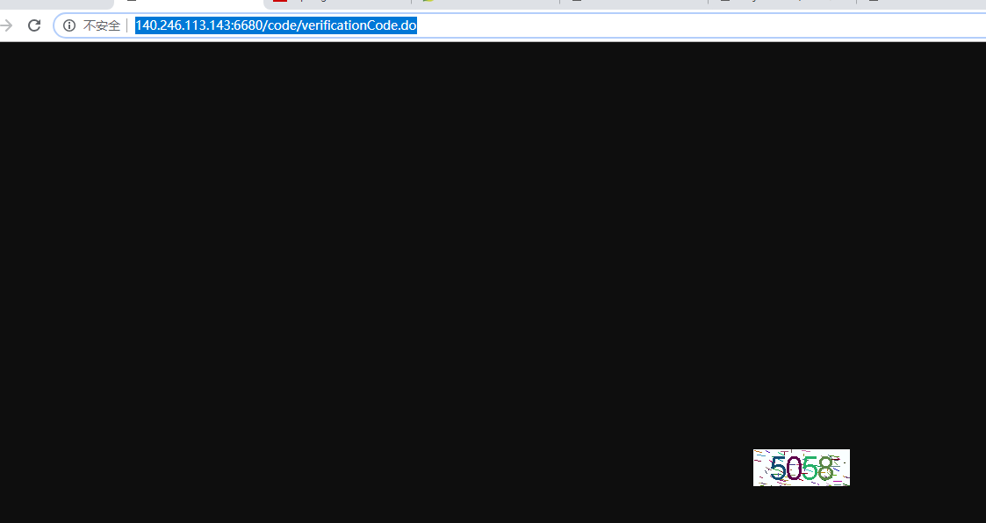
2, Call Login API, loginCode is got from above step.
http://140.46.13.43:6680/user/login.do?userAccount=admin1&password=000000&loginCode=5058

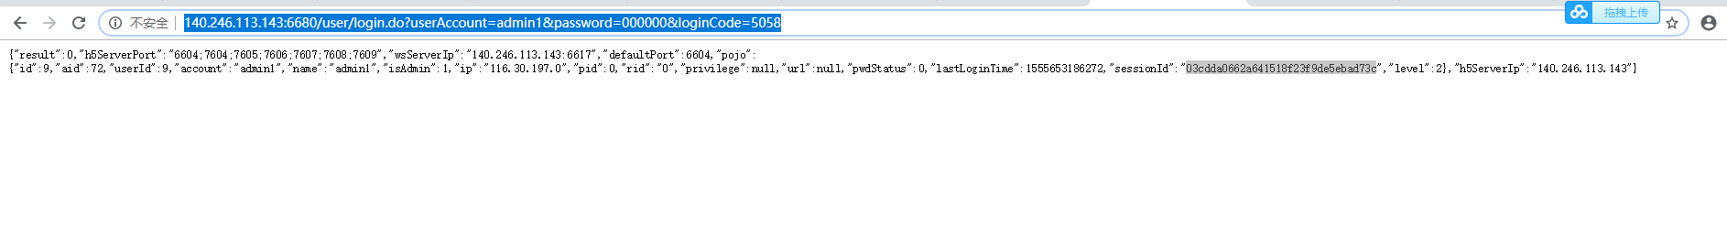
sessionId":"03cdda0662a641518f23f9de5ebad73c

3,Open demo
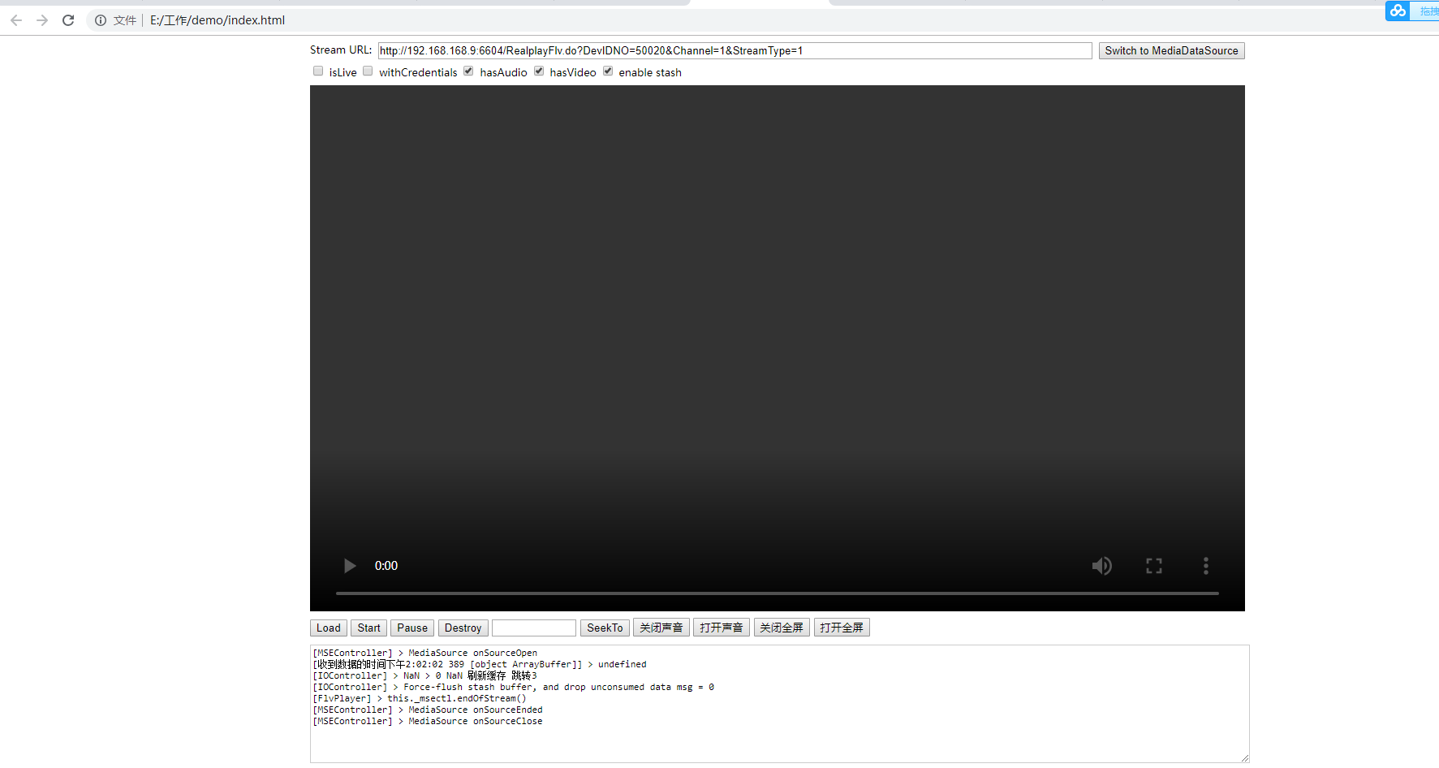
uSession = sessionId
http://140.46.13.43:6604/RealplayFlv.do?DevIDNO=50020&Channel=1&StreamType=1&uSession=03cdda0662a641518f23f9de5ebad73c

